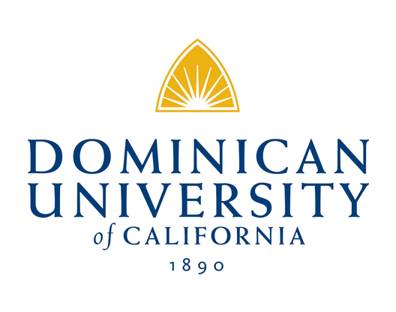

Mission
Dominican University of California transforms lives. We are an independent, learner-centered, international university of Catholic heritage, which interweaves Dominican values, the liberal arts and sciences, and the skills and knowledge necessary to live and work in an interdependent world.

Department of Natural Science and Mathematics
Chemistry and Biology Research Methodology I

BIO 2990.5 – 1 Unit_Spring 2026
Fridays, 9:00 am – 11:30 am
Location: Science Building Rm 107

Instructors:
Tyler Johnson, PhD Matthew Nickel, BSc
Associate Professor of Chemistry Graduate Student & Adjunct Faculty
email: tyler.johnson@dominican.edu email: Matthew.Nickel@dominican.edu
Office Location: Science Building Rm 128 Office Location: Science Building Rm 110
Office Hours: Mon & Wed 12:00-1:00 pm (Zoom) Office Hours: Wed 1:00-2:00 pm

Research Group - Team Leaders (Consultants):
1) Matthew Nickel email: matthew.nickel@dominican.edu
2) Natalie Oyler email: natalie.oyler@students.dominican.edu
2) Victoria Barlow email: victoria.barlow@students.dominican.edu
3) Brisa Navarette email: brisa.navarretesandoval@students.dominican.edu
3) Brooke Young email: brooke.young@students.dominican.edu
4) Linel Tolentino email: linel.tolentino@students.dominican.edu
4) Angelly Escalante email: angelly.escalante@students.dominican.edu

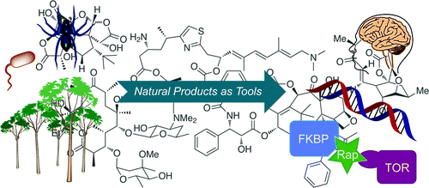
I. Research Description: Natural products chemistry has served as the backbone for modern therapeutic development programs since the dawn of the pharmaceutical age. Compounds derived from plants and microorganisms have enjoyed a rich history for providing inspiration for most of the molecules we use in medicine today. Marine natural products from the ocean represent an underexplored source to investigate lead compounds for discovery in this area. Many are now being pursued as therapeutic lead structures for drug development, and a small but growing number have also gone on to serve as important chemical probes (tool compounds) in chemical biology research. Chemical biology is a burgeoning field at the interface of chemistry, biology and biomedical research. It uses structurally distinct compounds, which serve as chemical probes for specifically disrupting the cell cycle, to address fundamental questions in molecular, cellular and developmental biology. The long range goal of our laboratory is to purify natural products from marine sponge extracts and prepare them to be screened
as libraries of pure compounds against new disease targets to search for:
a) therapeutic lead structures in biomedical research and b) novel probes in chemical biology. Basic methodology for how to prepare marine extracts to isolate pure compounds for biomedical research will be presented.

1

II. Course Materials:
- All materials will be provided by the instructor. It is the student’s responsibility to obtain and read this material. The majority of the readings will be accessible online (Google), through Moodle, research lab website or scientific databases available from DUC Library.

III. Learning/Teaching Methods and Student Expectations: Subject material will be covered through lecture, discussion and computer experiments. Students are responsible for reading the relevant journal articles and reviews assigned in order to develop an understanding of their specific research topic. Students are expected to attend every class session and play an active role in carrying out the proposed experiments related to their research project.
IV. Grading: Grades will be distributed as follows:
- Scientific Article Summaries 20 pts Due Day 2
- Mini research project 20 pts Due Day 2
- Power point reports 20 pts Due Day 2
- Rotation Summary 20 pts Due (see p. 5)
- Course reflection 20 pts Due (see p. 5)
100 pts

- Tentative Schedule

Rotation Day 1: 10 min. - Introductions, syllabus, review article - Marine Natural Products Chemistry (read at home - answer Qs),
Friday 20 min. - Assign sponges to groups 1-3. Turbo extraction of sponge (MeOH, soak 3 hrs) – consultants assist
1 hr - Introduction to marine natural products chemistry & chemical biology.

- 5 min. intermission

5 min. Assign Marine Drugs research articles to groups: (electronic copies on research lab webpage)
15 min - Mini lecture on marine natural products extraction and polarity &
30 min - Tutorial on how to prepare a powerpoint presentation (electronic examples on research lab webpage)

10 min. – pour off Methanol extractions into trays (consultants assist) to generate total polar extract (TPE).

Adjourn ~ 11:30am

Homework: Read: Marine natural products chemistry review article ~ answer questions
Due Day 2 Read: Marine Drugs research articles and answer the worksheet questions
Prepare: mini (~10 min.) powerpoint presentation of their sponge reporting on:
1) where it is collected (biogeographical variations),
2) what type of: a) polar & b) non polar chemistry it possess (show the structures),
3) what biological (disease) targets does associated chemistry of the sponge effect

Note: Powerpoint Research talks (15 min. max, 7-10 slides) have fun with it
ALL SCIENTIFIC PRESENTATIONS MUST BE MADE USING “Powerpoint”. No exceptions. Otherwise 5 pts off.
Selected examples of previous sponge-derived chemistry powerpoint presentations – on research lab webpage

Rotation Day 2:
Friday 30 min. - Review Questions of review article

1 hr - Extract TPE layer in tray (consultants assist) of selected sponges using Water (W) &
Dichloromethane (DCM). Solvent partition into separatory funnels, invert and let sit, 30 min.
Drain into 2 beakers labeled as the polar water (W) and non-polar fat (F) layers.

30 min - Photograph color differences of the W vs F fractions in each beaker to determine qualitatively which
extract (the W or F) beaker is more likely enriched with either the polar or non polar chemistry reported from each of your groups assigned Marine drugs research papers. (consultants assist)

Add the above photographs to your powerpoint presentations.
***Note: make sure you highlight your proposed [chemistry] data here using the photos is
qualitative (observation based) and NOT quantitative (numerically or quantifiably derived)

1 hr - Powerpoint presentations (≤15 min.) – 20 pts - students grade each other ~ (rubric provided)

DONE NOTES: Syllabus and Schedule subject to change ~ Thank you for being flexible.
2

Student Learning Outcomes:
1. Comprehension and integration of fundamental scientific concepts in the biological and physical sciences.
2. The ability to perform techniques in modern science.
3. The ability to apply scientific and mathematical principles in developing an independent research project, utilizing
appropriate scientific techniques, including information and data analysis technology.
4. Objectivity in scientific investigations by suspending preliminary judgments, drawing conclusions only from observable
and testable data, and attempting to exclude cultural assumptions and biases.
5. Understanding of a spectrum of chemical principles and knowledge in all major areas of chemistry.
6. Skills in analysis, synthesis, and quantitative reasoning that are essential to establish and rigorously test hypotheses.
7. Competency in working in a chemistry laboratory, especially with respect to:
a. general laboratory practice guidelines, including safety and standard operating procedures (SOPS)
b. qualitative and quantitative chemical analyses, extraction and solvent partitioning
8. The ability to organize and present chemical information in written and oral format using available information technology.
9. Understanding of the importance of chemistry in society, environment and industry.
10. The skills necessary to pursue employment or further education involving inter-disciplinary areas of biomedical research.

Student Learning Outcomes:
- Comprehension and integration of fundamental scientific concepts in the biological and physical sciences.
- The ability to perform techniques in modern science.
- The ability to apply scientific and mathematical principles in developing an independent research project, utilizing appropriate scientific techniques, including information and data analysis technology.
- Objectivity in scientific investigations by suspending preliminary judgments, drawing conclusions only from observable and testable data, and attempting to exclude cultural assumptions and biases.
- Understanding of a spectrum of chemical principles and knowledge in all major areas of chemistry.
- Skills in analysis, synthesis, and quantitative reasoning that are essential to establish and rigorously test hypotheses.
- Competency in working in a chemistry laboratory, especially with respect to:
a. general laboratory practice guidelines, including safety
b. qualitative and quantitative chemical analyses, reactions, and synthesis; and
c. the use of modern chemical instrumentation
8. The ability to organize & present chemical information in written & oral format using the available information technology.
9. Understanding of the importance of chemistry in society, environment and industry.
10. The skills necessary to pursue employment or further education in chemistry or inter-disciplinary areas involving chemistry.

Rotation no. Consultant name(s)/group(s) Assigned Genus & 2-3 students/group
1 Matt Theonella
1 NEO/Victoria Jaspis
1 Brisa/Brooke Haliclona
1 Linel/Angelly Plakortis
2 Matt Haliclona
2 NEO/Victoria Plakortis
2 Brisa/Brooke Theonella
2 Linel/Angelly Jaspis
3 Matt Jaspis
3 NEO/Victoria Haliclona
3 Brisa/Brooke Plakortis
3 Linel/Angelly Theonella
4 Matt Plakortis
4 NEO/Victoria Theonella
4 Brisa/Brooke Jaspis
4 Linel/Angelly Haliclona

3
3

4

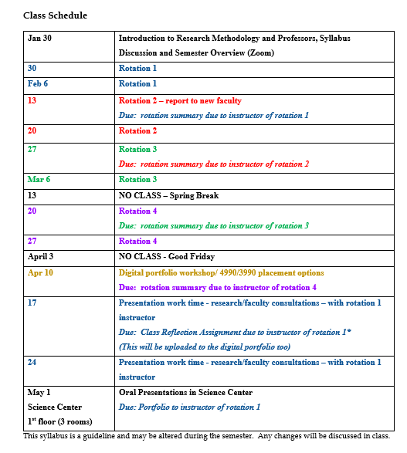

5

